MY EXPERIENCE AT EUROPEAN INSTITUTE OF ONCOLOGY (IEO)

The European Institute of Oncology (IEO) is the fastest growing cancer center in Europe and the most prestigious cancer center in the world, located in Milan, Italy. The prevention, diagnosis and treatment of cancer integrates various areas where education, training and research in oncology are carried out. The European Oncology Institute, which specializes in the field of oncology, is ranked first in Italy and in the top twenty worldwide in the "World's Best Specialized Hospitals 2024" ranking.
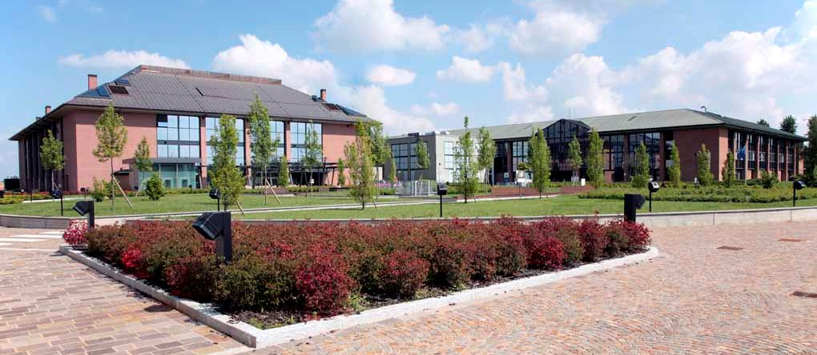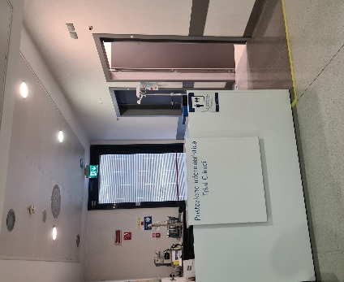

I am İlayda Eroğlu. I worked as a clinical nurse in a medical oncology clinic in a state hospital in Turkey for about two years. While working here, I completed my master's thesis about the effect of exercise on chemotherapy induced peripheral neuropathy symptom. I am currently a research assistant at Ankara University Faculty of Nursing. I am continuing doctoral education and doing researches in the fields of oncology nursing and internal medicine nursing. Oncology nurses are health professionals who have an active role in improving the quality of life of patients, palliative care, administering cancer-specific treatment, managing the side effects of treatments, early diagnosis, cancer prevention and treatment of cancer. I think it is extremely important for oncology nurses to specialize, conduct research in this field, and support their education in improving the quality of life and care of cancer patients. My aim was to make clinical observations in a hospital in Europe that specializes in oncology and where current clinical trials are carried out when I applied for the ESO-EONS Clinical Fellowship, and I found this in IEO.
The importance of clinical trials in the treatment of cancer is increasing day by day and I believe that nurses should play an active role in the conduct of clinical trials at every stage. However, today, there is no common system in the world regarding the roles of nurses in clinical studies and their responsibilities in conducting the trials. At IEO, I had the chance to observe first-hand a system in which oncology nurses have active roles and responsibilities within the research team in clinical trials. In this system, nurses have a role in conducting clinical trials on different solid tumors. I observed clinical trial nurses in gynecological oncology, breast cancer, gastrointestinal cancers, melanoma-lung cancers while conducting phase 2 and phase 3 clinical trials. At IEO, I observed phase 2 and phase 3 studies from nurses who were specialized in different types of cancer and experienced in their fields. I learned about the roles of nurses in these trials. I also followed how phase 1 studies, in which new treatments are investigated on humans, are conducted after preclinical studies. Together with the expert nurses conducting phase 1 studies, I observed drug administration, clinical trial protocols (including the inclusion and exclusion processes of patients), patient follow-up, the process of recruiting patients to phase 1 studies, and the active role of nurses in these stages of different trial protocols. I also had the chance to observe that the roles of clinical trial nurses are not limited to the conduct of the trial, but also their effective communication with patients and the patient education they provide on side effects. In addition, I observed the application of preventive drug treatments and the patient follow-up process with breast cancer clinical trial nurses. Thus, I learned the roles and responsibilities of clinical study nurses in preventive treatment. I realized that the clinical trial nursing system in patient care and cancer treatment should be widespread all over the world because clinical trial nurses are actively at the center of the trials, not as an auxiliary member of the trials. With the professional knowledge and experience of specialist nursing, I realized the importance of conducting clinical trials in investigating the effectiveness of new cancer treatments. Clinical trial nursing; I came to the conclusion that it is a new field open to development, that it is a new field of specialization in terms of oncology nursing, and that nurses working in this field should be supported more in terms of education and their numbers should increase.
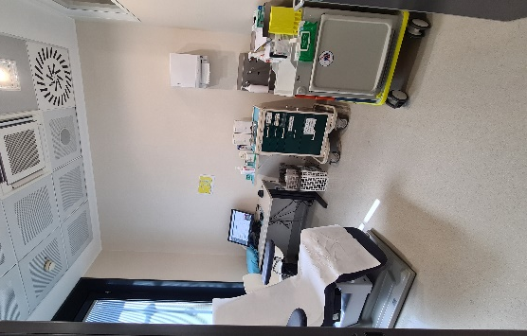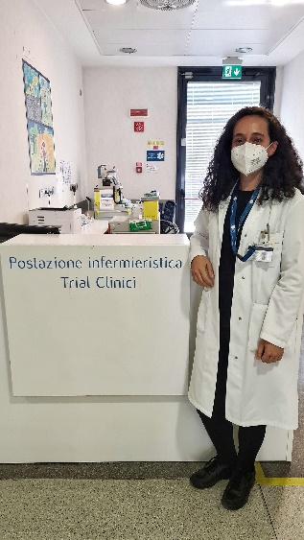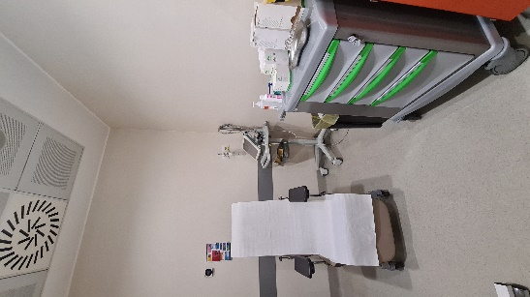

I consider that the observations I made at IEO contributed to my career as a research assistant and a former clinical oncology nurse. Thanks to this fellowship, attending the IEO in Milan and meeting a professional and expert nurse team was an unforgettable experience for me. I would like to thank Alice Ciocchini at ESO and Nurse Silvia Mauri at IEO for their kind assistance and all the clinical trial nurses for providing me to clinical observations. I would like to thank the Oncology Nurses Association of Turkey (OHD) for making me aware of this fellowship, EONS and ESO for providing me with this fellowship, for choosing me from Turkey, for contributing to my career, and for learning, sharing and developing as a research assistant continuing doctoral education. Thank you for giving me the wonderful opportunity.

