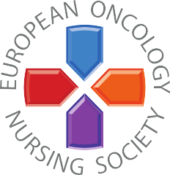

[Insert name of Society and address]

[Insert date]

Transforming Cancer Nursing Education In Our Country

Dear Minister (insert name),

The European Oncology Nursing Society (EONS) is committed to the support and development of cancer nurses. We believe strongly in the need for well-educated cancer nurse professionals in cancer care. Currently cancer nurses across Europe face extreme inequality of access to professional education and training – EONS’ vision is that cancer nursing should be a profession with specialised training and qualifications available across the continent.

There is growing evidence and awareness that a well-formed education curriculum is needed in order to provide high quality cancer care across Europe, now and for the future. To address this need, EONS has developed the EONS Cancer Nursing Education Framework.

The European Cancer Nursing Education Framework¹ is a free tool that provides a harmonised approach to cancer nurse education in order to train well-educated cancer nurse professionals, set a common standard across Europe and, at the same time, strengthen cancer care within individual countries.

The Framework is particularly intended to provide guidance for structuring the learning content of cancer nursing programmes: it comprises eight modules which identify the fundamental knowledge and skills required for post-registration nurses working with people affected by cancer.

Therefore, we would like to ask the Government of [Insert country]
to promote the EONS Cancer Nursing Education Framework as a vital resource that must be used by all individuals and teams involved in the education, training and professional development of cancer nurses in our country and across Europe.

To that end, we hope that a consultation can be planned in the near future, and we would appreciate being included in your consultative process.

Respectfully,

[Insert name and contact details]

1 You can download a copy of the EONS European Cancer Nursing Education Framework at www.cancernurse.eu/education/cancernursingeducationframework.html

